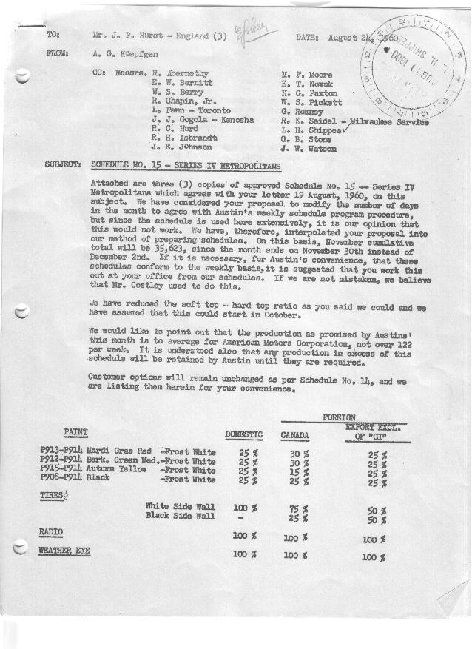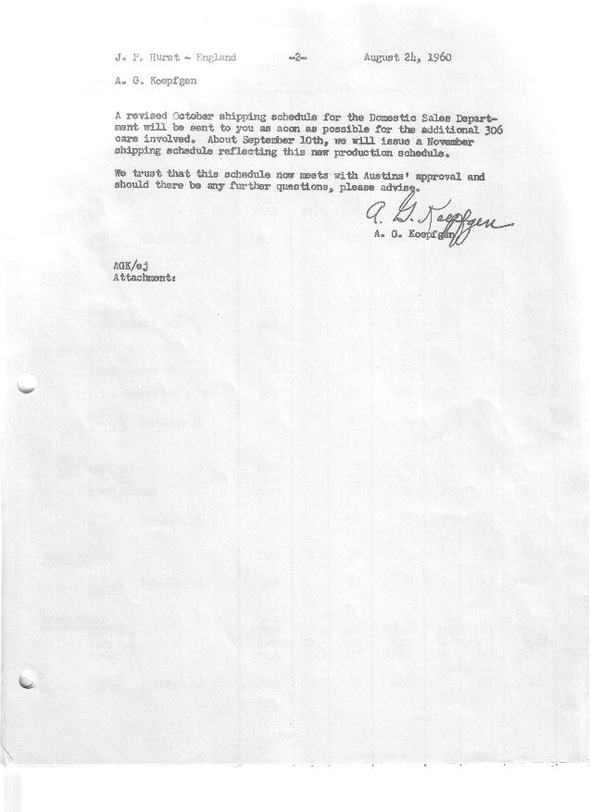

FORM AM 1262 Page 1 of 4 APPROVED R. Abernethy (signed) DATE 8-26-60

SCHEDULE NO. ______15 ___ DATE 8-24-60 MONTHLY BUILDING SCHEDULE APPROVED E.W.Bernitt (signed) DATE_ 8-29-60 _
REVISION NO. _______ __ ____ DATE PRODUCT APPROVED R. W.Chapin Jr. (signed) DATE 8-29-60 _
SERIES IV 1500 c.c. ENGINE
METROPOLITAN SERIES CARS – AUSTIN MOTORS CO., LTD, ENGLAND
DESCRIPTION | BUILT  ◻ACT EST  THRU  JULY | FIRM BUILDING SCHEDULE  (FABRICATED MATERIAL RELEASE) |  |  |  |  |  |  |  |  |  |  |  |  |  |  | TENTATIVE SCHEDULE  (RAW MATERIAL RELEASED) |  |  | GRAND  TOTAL
DESCRIPTION | BUILT  ◻ACT EST  THRU  JULY | MONTH AUGUST ‘60  DAYS 18 |  |  | MONTH SEPTEMBER  DAYS 22 |  |  | MONTH OCTOBER  DAYS 21 |  |  | MONTH NOVEMBER  DAYS 22 |  |  | MONTH DECEMBER  DAYS 20 (was 21) |  |  | MONTH JANUARY ‘61  DAYS 22 |  |  | GRAND  TOTAL
DESCRIPTION | BUILT  ◻ACT EST  THRU  JULY | DAILY | MONTH | CUM’L  TOTAL | DAILY | MONTH | CUM’L  TOTAL | DAILY | MONTH | CUM’L  TOTAL | DAILY | MONTH | CUM’L  TOTAL | DAILY | MONTH | CUM’L  TOTAL | DAILY | MONTH | CUM’L TOTAL | GRAND  TOTAL
DOMESTIC LHD:
Hard-Top | 23274 |  | 85 | 23359 |  | 303 | 23662 |  | 435 | 24097 |  | 484 | 24581 |  | 494 | 25075 |  | 281 | 25356
Soft-Top | 7627 |  | 322 | 7949 |  | 302 | 8251 |  | 100 | 8351 |  | 60 | 8411 |  | 51 | 8462 |  | 281 | 8743
Total U.S. | 30901 | 22.6 | 407 | 31308 | 27.5 | 605 | 31913 | 25.5 | 535 | 32448 | 24.7 | 544 | 32992 | 27.3 | 545 | 33537 | 25.6 | 562 | 34099
Over/(Under) Schedule 14 | 230 |  | (20) | 210 |  | 64 | 274 |  | 32 | 306 |  | 3 | 309 |  | (29) | 280 |  | -0- | 280
FOREIGN:
EXPORT LHD Hard-Top | 271 |  | 11 | 282 |  | 8 | 290 |  | 8 | 298 |  | 8 | 306 |  | 8 | 314 |  | 8 | 322
Soft-Top | 106 |  | 0 | 106 |  | 0 | 106 |  | 3 | 109 |  | 3 | 112 |  | 3 | 115 |  | 3 | 118
Total Export LHD | 377 |  | 11 | 388 |  | 8 | 396 |  | 11 | 407 |  | 11 | 418 |  | 11 | 429 |  | 11 | 440
RHD Hard Top | 54 |  | 4 | 58 |  | 3 | 61 |  | 3 | 64 |  | 3 | 67 |  | 3 | 70 |  | 3 | 73
Soft Top | 22 |  | 0 | 22 |  | 0 | 22 |  | 1 | 23 |  | 1 | 24 |  | 1 | 25 |  | 1 | 26
Total Export RHD | 76 |  | 4 | 80 |  | 3 | 83 |  | 4 | 87 |  | 4 | 91 |  | 4 | 95 |  | 4 | 99
Total Export LHD & RHD | 453 | .9 | 15 | 468 | .5 | 11 | 479 | .7 | 15 | 494 | .7 | 15 | 509 | .7 | 15 | 524 | .7 | 15 | 539
Over/(Under) Schedule 14 | 4 |  | -0- | 4 |  | (4) | -0- |  | -0- | -0- |  | -0- | -0- |  | -0- | -0- |  | -0- | -0-
CANADA Hard-Top | 1560 |  | 0 | 1560 |  | 67 | 1627 |  | 80 | 1707 |  | 70 | 1777 |  | 10 | 1787 |  | 40 | 1827
Soft-Top | 330 |  | 15 | 345 |  | 0 | 345 |  | 0 | 345 |  | 0 | 345 |  | 0 | 345 |  | 10 | 355
Total Canada | 1890 | .8 | 15 | 1905 | 3.0 | 67 | 1972 | 3.8 | 80 | 2052 | 3.2 | 70 | 2122 | .5 | 10 | 2132 | 2.2 | 50 | 2182
Over/(Under) Schedule 14 | 58 |  | (55) | 3 |  | (3) | -0- |  | -0- | -0- |  | -0- | -0- |  | -0- | -0- |  | -0- | -0-
Total Foreign | 2343 | 1.7 | 30 | 2373 | 3.5 | 78 | 2451 | 4.5 | 95 | 2546 | 3.9 | 85 | 2631 | 1.2 | 25 | 2656 | 2.9 | 65 | 2721
Over/(Under) Schedule 14 | 62 |  | (55) | 7 |  | (7) | -0- |  | -0- | -0- |  | -0- | -0- |  | -0- | -0- |  | -0- | -0-
GRAND TOTALS
Hard-Top | 25159 | 5.6 | 100 | 25259 | 17.3 | 381 | 25640 | 25.0 | 526 | 26166 | 25.7 | 565 | 26731 | 25.8 | 515 | 27246 | 15.1 | 332 | 27578
Soft-Top | 8085 | 18.7 | 337 | 8422 | 13.7 | 302 | 8724 | 5.0 | 104 | 8828 | 2.9 | 64 | 8892 | 2.7 | 55 | 8947 | 13.4 | 295 | 9242
Total | 33244 | 24.3 | 437 | 33681 | 31.0 | 683 | 34364 | 30.0 | 630 | 34994 | 28.6 | 629 | 35623 | 28.5 | 570 | 36193 | 28.5 | 627 | 36820
Over/(Under) Schedule 14 | 292 |  | (75) | 217 |  | 57 | 274 |  | 32 | 306 |  | 3 | 309 |  | (29) | 280 |  | -0- | 280

FORM AM 1262 Page 2 of 4 APPROVED R. Abernethy (signed) DATE 8-26-60

SCHEDULE NO. ______15 ___ DATE 8-24-60 MONTHLY BUILDING SCHEDULE APPROVED E.W.Bernitt (signed) DATE_ 8-29-60 _
REVISION NO. _______ __ ____ DATE PRODUCT APPROVED R. W.Chapin Jr. (signed) DATE 8-29-60 _
SERIES IV 1500 c.c. ENGINE
METROPOLITAN SERIES CARS – AUSTIN MOTORS CO., LTD, ENGLAND
DESCRIPTION | BUILT  ◻ACT◻ EST  THRU | FIRM BUILDING SCHEDULE  (FABRICATED MATERIAL RELEASE) |  |  |  |  |  |  |  |  |  |  |  |  |  |  | TENTATIVE SCHEDULE  (RAW MATERIAL RELEASED) |  |  | GRAND  TOTAL
DESCRIPTION | BUILT  ◻ACT◻ EST  THRU | MONTH FEBRUARY ‘61  DAYS 20 |  |  | MONTH MARCH  DAYS 23 |  |  | MONTH APRIL  DAYS 18 |  |  | MONTH MAY  DAYS 21 |  |  | MONTH JUNE  DAYS 22 |  |  | MONTH JULY  DAYS 15 |  |  | GRAND  TOTAL
DESCRIPTION | BUILT  ◻ACT◻ EST  THRU | DAILY | MONTH | CUM’L  TOTAL | DAILY | MONTH | CUM’L  TOTAL | DAILY | MONTH | CUM’L  TOTAL | DAILY | MONTH | CUM’L  TOTAL | DAILY | MONTH | CUM’L  TOTAL | DAILY | MONTH | CUM’L TOTAL | GRAND  TOTAL
DOMESTIC LHD:
Hard-Top |  |  | 240 | 25596 |  | 265 | 25861 |  | 233 | 26094 |  | 356 | 26450 |  | 393 | 26843 |  | 236 | 27079
Soft-Top |  |  | 240 | 8983 |  | 265 | 9248 |  | 155 | 9403 |  | 152 | 9555 |  | 169 | 9724 |  | 101 | 9825
Total U.S. |  | 24.0 | 480 | 34579 | 23.1 | 530 | 35109 | 21.6 | 388 | 35497 | 24.2 | 508 | 36005 | 25.5 | 562 | 36567 | 22.5 | 337 | 36904
Over/(Under) Schedule 14 |  |  | -0- | 280 |  | -0- | 280 |  | -0- | 280 |  | -0- | 280 |  | -0- | 280 |  | -0- | 280
FOREIGN:
EXPORT LHD Hard-Top |  |  | 8 | 330 |  | 8 | 338 |  | 8 | 346 |  | 8 | 354 |  | 8 | 362 |  | 8 | 370
Soft-Top |  |  | 3 | 121 |  | 3 | 124 |  | 3 | 127 |  | 3 | 130 |  | 3 | 133 |  | 3 | 136
Total Export LHD |  |  | 11 | 451 |  | 11 | 462 |  | 11 | 473 |  | 11 | 484 |  | 11 | 495 |  | 11 | 506
RHD Hard Top |  |  | 3 | 76 |  | 3 | 79 |  | 3 | 82 |  | 3 | 85 |  | 3 | 88 |  | 3 | 91
Soft Top |  |  | 1 | 27 |  | 1 | 28 |  | 1 | 29 |  | 1 | 30 |  | 1 | 31 |  | 1 | 32
Total Export RHD |  |  | 4 | 103 |  | 4 | 107 |  | 4 | 111 |  | 4 | 115 |  | 4 | 119 |  | 4 | 123
Total Export LHD & RHD |  | .8 | 15 | 554 | .7 | 15 | 569 | .8 | 15 | 584 | .7 | 15 | 599 | .7 | 15 | 614 | 1.0 | 15 | 629
Over/(Under) Schedule 14 |  |  | -0- | -0- |  | -0- | -0- |  | -0- | -0- |  | -0- | -0- |  | -0- | -0- |  | -0- | -0-
CANADA Hard-Top |  |  | 60 | 1887 |  | 45 | 1932 |  | 55 | 1987 |  | 55 | 2042 |  | 50 | 2092 |  | 75 | 2167
Soft-Top |  |  | 15 | 370 |  | 65 | 435 |  | 55 | 490 |  | 20 | 510 |  | -0- | 510 |  | 0 | 510
Total Canada |  | 3.7 | 75 | 2257 | 4.7 | 110 | 2367 | 6.1 | 110 | 2477 | 3.6 | 75 | 2552 | 2.3 | 50 | 2602 | 5.0 | 75 | 2677
Over/(Under) Schedule 14 |  |  | -0- | -0- |  | -0- | -0- |  | -0- | -0- |  | -0- | -0- |  | -0- | -0- |  | -0- | -0-
Total Foreign |  | 4.5 | 90 | 2811 | 5.4 | 125 | 2936 | 6.9 | 125 | 3061 | 4.3 | 90 | 3151 | 3.0 | 65 | 3216 | 6.0 | 90 | 3306
Over/(Under) Schedule 14 |  |  | -0- | -0- |  | -0- | -0- |  | -0- | -0- |  | -0- | -0- |  | -0- | -0- |  | -0- | -0-
GRAND TOTALS
Hard-Top |  | 15.6 | 311 | 27889 | 14.0 | 321 | 28210 | 16.6 | 299 | 28509 | 20.1 | 422 | 28931 | 20.6 | 454 | 29385 | 21.5 | 322 | 29707
Soft-Top |  | 12.9 | 259 | 9501 | 14.5 | 334 | 9835 | 11.9 | 214 | 10049 | 8.4 | 176 | 10225 | 7.9 | 173 | 10398 | 7.0 | 105 | 10503
Total |  | 28.5 | 570 | 37390 | 28.5 | 655 | 38045 | 28.5 | 513 | 38558 | 28.5 | 598 | 39156 | 28.5 | 627 | 39783 | 28.5 | 427 | 40210
Over/(Under) Schedule 14 |  |  | -0- | 280 |  | -0- | 280 |  | -0- | 280 |  | -0- | 280 |  | -0- | 280 |  | -0- | 280

FORM AM 1262 Page 3 of 4 APPROVED R. Abernethy (signed) DATE 8-26-60

SCHEDULE NO. ______15 ___ DATE 8-24-60 MONTHLY BUILDING SCHEDULE APPROVED E.W.Bernitt (signed) DATE_ 8-29-60 _
REVISION NO. _______ __ ____ DATE PRODUCT APPROVED R. W.Chapin Jr. (signed) DATE 8-29-60 _
SERIES IV 1500 c.c. ENGINE
METROPOLITAN SERIES CARS – AUSTIN MOTORS CO., LTD, ENGLAND
DESCRIPTION | BUILT  ◻ACT◻ EST  THRU | FIRM BUILDING SCHEDULE  (FABRICATED MATERIAL RELEASE) |  |  |  |  |  |  |  |  |  |  |  |  |  |  | TENTATIVE SCHEDULE  (RAW MATERIAL RELEASED) |  |  | GRAND  TOTAL
DESCRIPTION | BUILT  ◻ACT◻ EST  THRU | MONTH AUGUST ‘61  DAYS 19 |  |  | MONTH SEPTEMBER  DAYS 21 |  |  | MONTH OCTOBER  DAYS 22 |  |  | MONTH NOVEMBER  DAYS 22 |  |  | MONTH DECEMBER  DAYS 18 |  |  | MONTH JANUARY ‘62  DAYS 23 |  |  | GRAND  TOTAL
DESCRIPTION | BUILT  ◻ACT◻ EST  THRU | DAILY | MONTH | CUM’L  TOTAL | DAILY | MONTH | CUM’L  TOTAL | DAILY | MONTH | CUM’L  TOTAL | DAILY | MONTH | CUM’L  TOTAL | DAILY | MONTH | CUM’L  TOTAL | DAILY | MONTH | CUM’L TOTAL | GRAND  TOTAL
DOMESTIC LHD:
Hard-Top |  |  | 309 | 27388 |  | 342 | 27730 |  | 362 | 28092 |  | 365 | 28457 |  | 342 | 28799 |  | 295 | 29094
Soft-Top |  |  | 132 | 9957 |  | 146 | 10103 |  | 155 | 10258 |  | 157 | 10415 |  | 146 | 10561 |  | 295 | 10856
Total U.S. |  | 23.3 | 441 | 37345 | 23.3 | 488 | 37833 | 23.5 | 517 | 38350 | 23.7 | 522 | 38872 | 27.1 | 488 | 39360 | 25.6 | 590 | 39950
Over/(Under) Schedule 14 |  |  | -0- | 280 |  | -0- | 280 |  | -0- | 280 |  | -0- | 280 |  | -0- | 280 |  | -0- | 280
FOREIGN:
EXPORT LHD Hard-Top |  |  | 8 | 378 |  | 8 | 386 |  | 8 | 394 |  | 8 | 402 |  | 8 | 410 |  | 8 | 418
Soft-Top |  |  | 3 | 139 |  | 3 | 142 |  | 3 | 145 |  | 3 | 148 |  | 3 | 151 |  | 3 | 154
Total Export LHD |  |  | 11 | 517 |  | 11 | 528 |  | 11 | 539 |  | 11 | 550 |  | 11 | 561 |  | 11 | 572
RHD Hard Top |  |  | 3 | 94 |  | 3 | 97 |  | 3 | 100 |  | 3 | 103 |  | 3 | 106 |  | 3 | 109
Soft Top |  |  | 1 | 33 |  | 1 | 34 |  | 1 | 35 |  | 1 | 36 |  | 1 | 37 |  | 1 | 38
Total Export RHD |  |  | 4 | 127 |  | 4 | 131 |  | 4 | 135 |  | 4 | 139 |  | 4 | 143 |  | 4 | 147
Total Export LHD & RHD |  | .8 | 15 | 644 | .7 | 15 | 659 | .7 | 15 | 674 | .7 | 15 | 689 | .8 | 15 | 704 | .7 | 15 | 719
Over/(Under) Schedule 14 |  |  | -0- | -0- |  | -0- | -0- |  | -0- | -0- |  | -0- | -0- |  | -0- | -0- |  | -0- | -0-
CANADA Hard-Top |  |  | 85 | 2252 |  | 95 | 2347 |  | 95 | 2442 |  | 90 | 2532 |  | 10 | 2542 |  | 40 | 2582
Soft-Top |  |  | -0- | 510 |  | -0- | 510 |  | 0 | 510 |  | 0 | 510 |  | 0 | 510 |  | 10 | 520
Total Canada |  | 4.4 | 85 | 2762 | 4.5 | 95 | 2857 | 4.3 | 95 | 2952 | 4.1 | 90 | 3042 | .6 | 10 | 3052 | 2.2 | 50 | 3102
Over/(Under) Schedule 14 |  |  | -0- | -0- |  | -0- | -0- |  | -0- | -0- |  | -0- | -0- |  | -0- | -0- |  | -0- | -0-
Total Foreign |  | 5.2 | 100 | 3406 | 5.2 | 110 | 3516 | 5.0 | 110 | 3626 | 4.8 | 105 | 3731 | 1.4 | 25 | 3756 | 2.9 | 65 | 3821
Over/(Under) Schedule 14 |  |  | -0- | -0- |  | -0- | -0- |  | -0- | -0- |  | -0- | -0- |  | -0- | -0- |  | -0- | -0-
GRAND TOTALS
Hard-Top |  | 21.3 | 405 | 30112 | 21.4 | 448 | 30560 | 21.3 | 468 | 31028 | 21.2 | 466 | 31494 | 20.2 | 363 | 31857 | 15.1 | 346 | 32203
Soft-Top |  | 7.2 | 136 | 10639 | 7.1 | 150 | 10789 | 7.2 | 159 | 10948 | 7.3 | 161 | 11109 | 8.3 | 150 | 11259 | 13.4 | 309 | 11568
Total |  | 28.5 | 541 | 40751 | 28.5 | 598 | 41349 | 28.5 | 627 | 41976 | 28.5 | 627 | 42603 | 28.5 | 513 | 43116 | 28.5 | 655 | 43771
Over/(Under) Schedule 14 |  |  | -0- | 280 |  | -0- | 280 |  | -0- | 280 |  | -0- | 280 |  | -0- | 280 |  | -0- | 280

FORM AM 1262 Page 4 of 4 APPROVED R. Abernethy (signed) DATE 8-26-60

SCHEDULE NO. ______15 ___ DATE 8-24-60 MONTHLY BUILDING SCHEDULE APPROVED E.W.Bernitt (signed) DATE_ 8-29-60 _
REVISION NO. _______ __ ____ DATE PRODUCT APPROVED R. W.Chapin Jr. (signed) DATE 8-29-60 _
SERIES IV 1500 c.c. ENGINE
METROPOLITAN SERIES CARS – AUSTIN MOTORS CO., LTD, ENGLAND
DESCRIPTION | BUILT  ◻ACT◻ EST  THRU | FIRM BUILDING SCHEDULE  (FABRICATED MATERIAL RELEASE) |  |  |  |  |  |  |  |  |  |  |  |  |  |  | TENTATIVE SCHEDULE  (RAW MATERIAL RELEASED) |  |  | GRAND  TOTAL
DESCRIPTION | BUILT  ◻ACT◻ EST  THRU | MONTH FEBRUARY ‘62  DAYS 17 |  |  | MONTH MARCH  DAYS 23 |  |  | MONTH APRIL  DAYS 3.2 (19 Available) |  |  | MONTH  DAYS |  |  | MONTH  DAYS |  |  | MONTH  DAYS |  |  | GRAND  TOTAL
DESCRIPTION | BUILT  ◻ACT◻ EST  THRU | DAILY | MONTH | CUM’L  TOTAL | DAILY | MONTH | CUM’L  TOTAL | DAILY | MONTH | CUM’L  TOTAL | DAILY | MONTH | CUM’L  TOTAL | DAILY | MONTH | CUM’L  TOTAL | DAILY | MONTH | CUM’L TOTAL | GRAND  TOTAL
DOMESTIC LHD:
Hard-Top |  |  | 197 | 29291 |  | 265 | 29556 |  | 90 | 29646
Soft-Top |  |  | 197 | 11053 |  | 265 | 11318 |  | -0- | 11318
Total U.S. |  | 23.2 | 394 | 40344 | 23.0 | 530 | 40874 | 28.5 | 90 | 40964
Over/(Under) Schedule 14 |  |  | -0- | 280 |  | -0- | 280 |  | (155) | 125
FOREIGN:
EXPORT LHD Hard-Top |  |  | 8 | 426 |  | 8 | 434 |  | 0 | 434
Soft-Top |  |  | 3 | 157 |  | 3 | 160 |  | 0 | 160
Total Export LHD |  |  | 11 | 583 |  | 11 | 594 |  | 0 | 594
RHD Hard Top |  |  | 3 | 112 |  | 3 | 115 |  | 0 | 115
Soft Top |  |  | 1 | 39 |  | 1 | 40 |  | 0 | 40
Total Export RHD |  |  | 4 | 151 |  | 4 | 155 |  | 0 | 155
Total Export LHD & RHD |  | .9 | 15 | 734 | .7 | 15 | 749 | 0.0 | 0 | 749
Over/(Under) Schedule 14 |  |  | -0- | -0- |  | -0- | -0- |  | (15) | (15)
CANADA Hard-Top |  |  | 60 | 2642 |  | 45 | 2687 |  | 0 | 2687
Soft-Top |  |  | 15 | 535 |  | 65 | 600 |  | 0 | 600
Total Canada |  | 4.4 | 75 | 3177 | 4.8 | 110 | 3287 | 0.0 | 0 | 3287
Over/(Under) Schedule 14 |  |  | -0- | -0- |  | -0- | -0- |  | (110) | (110)
Total Foreign |  | 5.3 | 90 | 3911 | 5.5 | 125 | 4036 | 0.0 | 0 | 4036
Over/(Under) Schedule 14 |  |  | -0- | -0- |  | -0- | -0- |  | (125) | (125)
GRAND TOTALS
Hard-Top |  | 15.8 | 268 | 32471 | 14.0 | 321 | 32792 | 28.5 | 90 | 32882
Soft-Top |  | 12.7 | 216 | 11784 | 14.5 | 334 | 12118 | 0.0 | 0 | 12118
Total |  | 28.5 | 484 | 44255 | 28.5 | 655 | 44910 | 28.5 | 90 | 45000
Over/(Under) Schedule 14 |  |  | -0- | 280 |  | -0- | 280 |  | (280) | -0-

